CWGC MEDIA PACK D-DAY 80

Contents
About the Commonwealth War Graves Commission (CWGC) 2
CWGC Spokespeople available for interview 7
The Legacy of Liberation 80 Campaign 10
Lighting Their Legacy 11
Where to see the torch – UK 12
CWGC Cemetery Lighting Their Legacy Events – Normandy 13
CWGC Service of Remembrance – Bayeux Cathedral 15
CWGC Lighting Their Legacy Procession 15
CWGC Great Vigil – Bayeux War Cemetery 16
For Evermore: Stories of the Fallen 17
Walking Our War Graves: Normandy 19
Sustainability at CWGC 21
Press Releases 24

About the Commonwealth War Graves Commission (CWGC)

- The CWGC is a global organisation, caring for war graves at 23,000 locations in more than 150 countries and territories. We commemorate almost 1.7 million individuals, ensuring that all the Commonwealth men and women who died during both world wars are commemorated in a manner befitting their sacrifice.

- Our global estate is run by a multinational and multilingual workforce numbering approximately 1,300 – the vast majority of whom are gardeners and stone masons.

- Since our establishment by Royal Charter we have constructed 2,500 war cemeteries and plots, erected headstones over graves and where the remains are missing, inscribed the names of the dead on permanent memorials. More than a million burials are now commemorated at military and civil sites around the world.

- Our work is constant, amending records, searching for missing names, building new memorials and where historical inequalities in commemoration are found, ensuring all those who fell are equally remembered.

- We also have a duty to ensure our sites remain well visited so remembrance of the war dead continues, creating information centres, volunteering opportunities and education programmes designed to engage and educate generations to come.

Our member nations



Our social media channels

X | @CWGC
Facebook | @commonwealth war graves commission
LinkedIn | @commonwealth war graves commission
Instagram | @commonwealthwargraves

CWGC in numbers
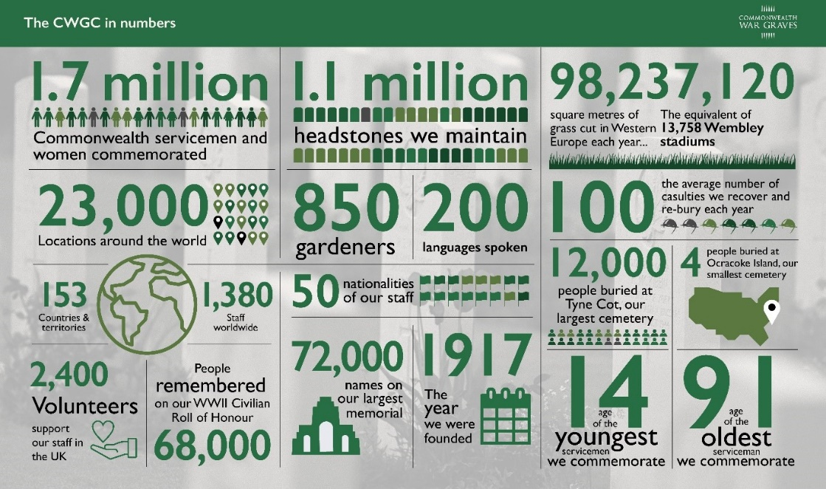
CWGC In Normandy

Bayeux Memorial | 1,798 commemorations
20 CWGC cemeteries | 25,080 commemorations
95 communal cemeteries | 362 commemorations
British Normandy Memorial  CWGC maintained site | 22,442 commemorations

CWGC Cemeteries in Normandy

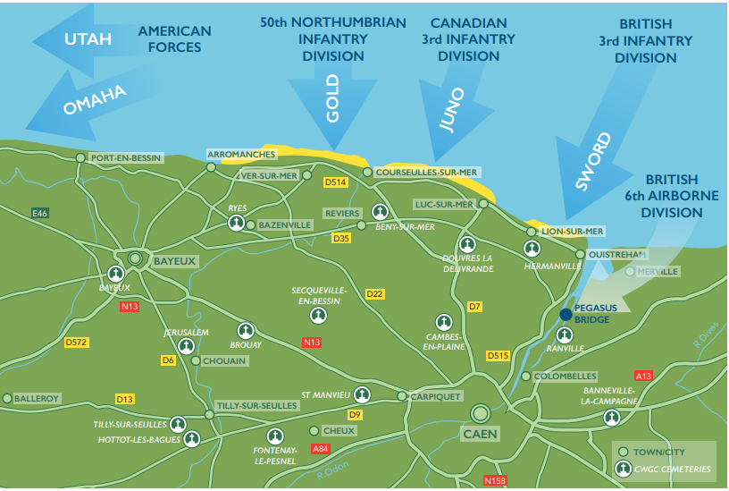

CWGC Key Contacts
Name | Email | Phone
CWGC Media Office | media@cwgc.org  cwgc@plmr.co.uk | +44 1628 507217

CWGC Events
Date | Event | Time
13th May | Lighting Their Legacy Torch events begin | TBC
3rd June | Lighting Their Legacy Torch leaves Portsmouth – arrives Normandy | TBC
4-5th June | Events across Normandy, all CWGC graves lit | See below
5th June | Bayeux Cathedral Service followed by procession to  Great Vigil – Bayeux War Cemetery (see more details below) | 19.00  21.30
6th June | CWGC Bayeux Cemetery service of remembrance (see more below) | 11.00

CWGC Spokespeople available for interview

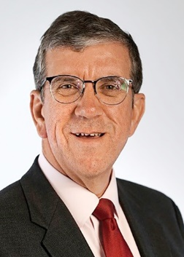
Vice Admiral Peter Hudson CB CBE
Vice Chairman
Peter Hudson joined the Commission in July 2019 and became Vice Chairman in July 2023. A former Vice Admiral in the Royal Navy; he held numerous commands during his 36-year career including three warships, the UK’s amphibious forces and multinational coalition operations in the Gulf. As a Flag Officer, his senior appointments included leading EU operations undertaking counter piracy operations off Somalia and serving as NATO’s
senior maritime commander for alliance wide maritime operations during which he was also a member of the UK Navy Board. On leaving the Service he spent 7 years in the Defence Industry, most latterly with BAE Systems where he was the company's Naval Advisor. He is National President of the Combined Cadet Force and is a Trustee of the Mary Rose Museum in Portsmouth.

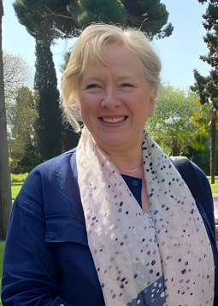
Claire Horton CBE
Director General
Claire Horton CBE is the Director General of the Commonwealth War Graves Commission. She took up the role in January 2021 having previously spent 11 years as Chief Executive of the national charity, Battersea Dogs and Cats Home. Claire has spent 30 years in charity management, leading organisations across multiple sectors, during which time, she has worked extensively with governments and building international partnerships with welfare organisations around the world.

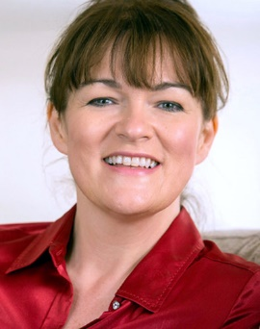
Michele Jennings
Chief Marketing Officer and Director of The Commonwealth War Graves Foundation
Michele joined the Commission in January 2023 after over a decade as Chief Executive of Hearing Dogs for Deaf People. She is a trustee of The Royal Grammar School Foundation, Assistance Dogs UK, and The Blue Cross. Michele can confidently speak on the work of the Foundation, which is the charitable arm of the Commonwealth War Graves Commission. Its mission is to make sure sacrifices are not forgotten by engaging and educating people especially the young – on the work of the Commonwealth War Graves Commission (CWGC) and the inspiring stories of the men and women who died whilst fighting in the two World Wars.

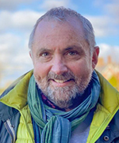
David Richardson
Director of Horticulture
David has worked for CWGC for over 30 years in all its global areas and has recently led initiatives on chemical reduction. He is a Chartered Fellow of the Institute of Horticulture, has served on the Institute’s Council, is a Liveryman of the Worshipful Company of Gardeners as well as being a Trustee of the Royal Botanic Gardens, Kew. David is a wonderful person to interview to understand the horticultural beauty and care of our sites.

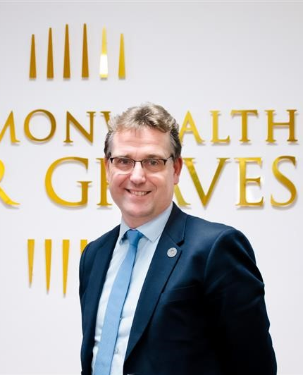
Xavier Puppinck
Area Director - France
Xavier Puppinck has been the Director of France Area since 2019 and has worked tirelessly since then to improve the Area’s performance as well as ensuring the organisation’s increased recognition by the French administration and public. Xavier has 15 years’ experience in international business and ten years managing industrial SMEs in France and in Europe. He is fluent in English, French, Dutch and German. He has a keen interest in History, especially WWI & II in Northern France and in Flanders. Throughout his career, he has developed strong management practices and communication skills. Xavier Puppinck holds a master’s degree in business administration from IAE in Lille and a major in International Business.

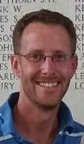
Simon Bendry
Head of Education and Engagement
Simon began his career teaching history in secondary schools but after 13 years in the classroom, he moved to UCL Institute of Education to work on the First World War Centenary Battlefield Tours Programme. Simon led the development of the award-winning education programme, including the prestigious tours as well as the highly regarded teacher CPD programme. In 2017, he took over as the programme director and worked on several national and international education and commemoration projects. Simon joined the Commonwealth War Graves Commission in 2020 where he now leads on education and community engagement. He is the spokesperson for the Lighting Their Legacy Torch Events.

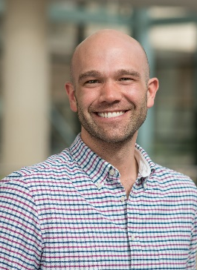
George Hay
Official Historian
George is an Honorary Academic at the University of Kent and a Fellow of the Royal Historical Society. He writes widely on the social history of British and Commonwealth armies in peace and war and works to generate greater understanding of the CWGC’s history, its sites and the casualties in its care. He authored the CWGC’s 2021 report on historical cases of non-commemoration and is continuing this work by leading the research strand of the ongoing Non-Commemoration Programme.

The Legacy of Liberation 80 Campaign

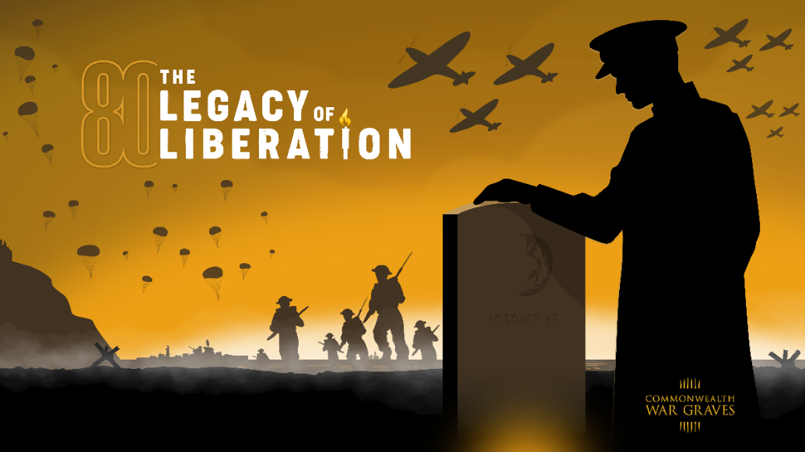
The “Legacy of Liberation 80” campaign presents a momentous opportunity to commemorate the 80th anniversaries of pivotal World War II events, with a special emphasis on D-Day.
The campaign aspires to cast a renewed emphasis on the act of remembrance, highlighting CWGC’s important role in honouring the human cost of these seminal historical moments.
The campaign captures several pivotal moments during World War II on the 80th anniversaries. From The Great Escape, war in the east, to the D-Day Landings, through to Victory in Europe and Japan, The Legacy of Liberation 80 remembers these remarkable events.
There are many ways the public can join us to mark these anniversaries throughout 2024 and 2025 – all details are on our interactive web hub: www.cwgc.org
At its heart, the initiative seeks to bridge the past and present, ensuring the stories of those who fell are passed on to younger generations, thereby fostering a deeper, more meaningful connection to our shared history.
This powerful campaign is designed to resonate deeply with a wide audience range, from veterans and their families to young people and international communities.
The innovative web hub drives awareness and interest through engaging storytelling, historical context, interactive tours of our key cemeteries, For Evermore which features stories from the people in the battles, details of our events and much more.

By focusing on humanising the connection to World War II and highlighting CWGC’s role in preserving these stories, the campaign will ignite a global conversation about the importance of remembrance.
Key anniversary events
- Great Escape – Poznan, Poland
- Battles of Kohima and Imphal – India
- Battle of Monte Cassino – Italy
- D-Day – France
- Battle of Arnhem – Netherlands
- Crossing The Rhine – Germany
- VE Day
- VJ Day

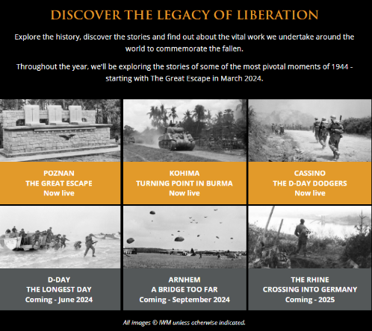
To visit the Legacy of Liberation website, click here

Lighting Their Legacy
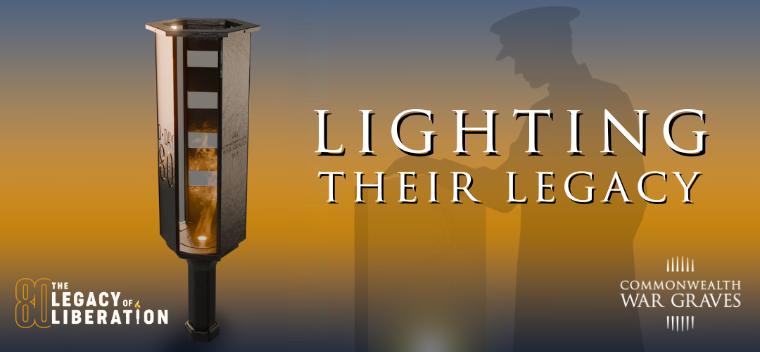

The Commonwealth War Graves Commission (CWGC) is proud to announce “Lighting Their Legacy”, a series of events and activities held at locations across the UK and Normandy throughout May and June.
The journey of the living flame of commemoration will start in Canada, travel to the UK where it officially launches on 13th May and will travel across the UK before joining D-Day veterans and heading across to Normandy. Upon arrival in Normandy, the torch will kick off another set of events where every CWGC grave will be lit in tribute to the fallen.
A symbol of our commitment to never forget the losses made for freedom, our torch relay will bring communities together, as we pass a flame of commemoration from veterans to the next generation and keep the stories of the fallen alive.

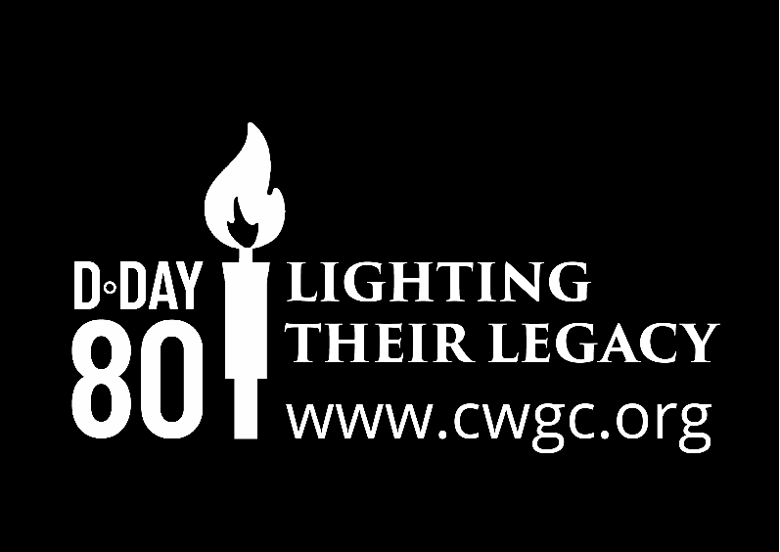

Where to see the torch – UK
13th May | National Memorial Arboretum | Staffordshire
14th May | Horse Guards TBC  HMS Belfast  Tower Hill Memorial  Trinity House | London
15th May | CWGC Plot – Botley Cemetery | Oxford
16th May | CWGC Plot – Cambridge Cemetery | Cambridge
17th May | CWGC Brookwood Military | Surrey
18th May | CWGC Chatham Naval Memorial | Kent
20th May | CWGC Plymouth Naval Memorial | Devon
21st May | CWGC Plot – Haycombe Cemetery | Bath
23rd May | Senedd | Cardiff
23rd May | CWGC Plot – Newark Cemetery | Newark-on-Trent
24th May | CWGC Plot – Harrogate Cemetery | Harrogate
29th May | Edinburgh Castle | Edinburgh
29th May | IWM North | Manchester
30th May | CWGC Runnymede Air Forces Memorial | Runnymede
3rd June | D-Day Museum | Portsmouth
4th June | Arrives Ouistreham Normandy | Normandy
5th June | Bayeux Cathedral  CWGC Bayeux War Cemetery | Bayeux
6th June | CWGC Bayeux War Cemetery | Bayeux

CWGC Cemetery Lighting Their Legacy Events – Normandy

CWGC Hermanville War Cemetery | 4 June | 21.00 | 6129 Rue du Cimetière Anglais, 14880 Hermanville-sur-Mer
CWGC Saint-Charles de Percy War Cemetery | 4 June | 22.00 | Saint-Charles de Percy war cemetery  14350 Valdallière
CWGC St Desir War Cemetery | 4 June | 21.00 | 122-332 Chem. De Malicorne À Ouilly le Vicomte, 14100 Saint-Désir
CWGC Cambes-en-Plaine War Cemetery | 4 June | 21.00 | 19 Rue du Mesnil Ricard, 14610 Cambes-en-Plaine
CWGC Tilly-sur-seulles War Cemetery | 4 June | 21.00 | 1945 D13  Bucéels, Normandie
CWGC Hottot-les-Bagues War Cemetery | 4 June | 21.00 | 12b D9, 14250 Tilly-sur-Seulles
CWGC Ryes War Cemetery | 4 June | 21.00 | D87, 14480 Bazenville
CWGC Fontenay-le-pesnel War Cemetery | 4 June | TBC | Fontenay-le-pesnel war cemetery  14250 Tessel
CWGC Saint-Manvieu War Cemetery | 4 June | 21.00 | Route de Saint-Manvieu, 14980 Rots
CWGC Sequeville-en-bessin War Cemetery | 4 June | 21.30 | Sequeville-en-bessin war cemetery  14740 Rots
CWGC Bretteville-sur-Laize Canadian War Cemetery | 4 June | 21.00 | N158, 14680 Cintheaux
CWGC Banneville La Campagne War Cemetery | 4 June | 21.00 | 13 Rte de Rouen, 14940 Banneville-la-Campagne
CWGC Ranville War Cemetery | 5 June | 20.00 – 22.00 | 1 Rue Comte Louis de Rohan-Chabot, 14860 Ranville
CWGC Jerusalem War Cemetery | 5 June | 22.30 | D6 Jerusalem War Cemetery  14250 Chouain
CWGC Ranville War Cemetery | 5 June | 20.00 – 22.00 | 1 Rue Comte Louis de Rohan-Chabot, 14860 Ranville
CWGC Jerusalem War Cemetery | 5 June | 22.30 | D6 Jerusalem War Cemetery  14250 Chouain
CWGC Beny-Reviers Canadian War Cemetery | 5 June | 22.30 | D35, 14470 Reviers
CWGC La Delivrande War Cemetery | 5 June | 22.30 | 37 Rte de Caen, 14440 Douvres-la-Délivrande
CWGC Brouay War Cemetery | Saturday  8 June | 10.00 | 7 L’Église, 14250 Thue et Mue

For more information click here

CWGC Service of Remembrance – Bayeux Cathedral
On behalf of the Ministry of Defence, CWGC will host the annual D-Day service of thanksgiving at Bayeux Cathedral. The event will include around 1,200 guests.

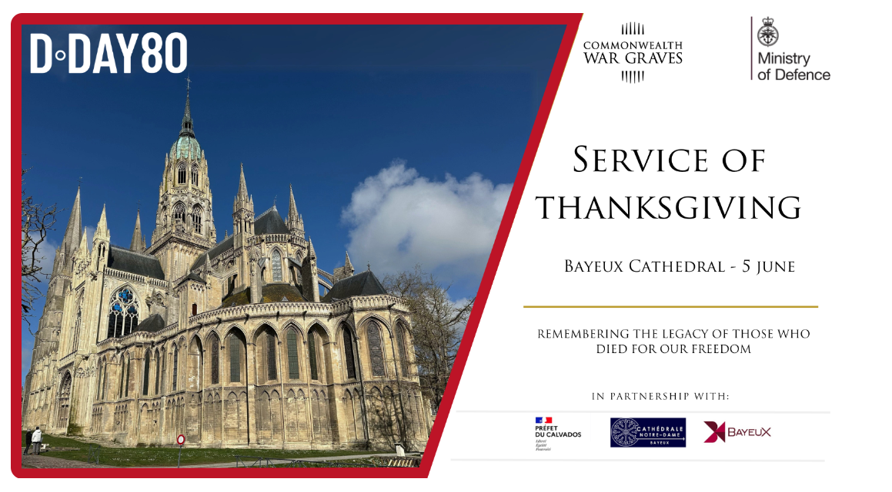

CWGC Lighting Their Legacy Procession 19.00
Following the Service of Remembrance guests will form part of a procession and make their way to CWGC Bayeux War Cemetery for the Great Vigil. Led by the CWGC torch the procession will feature an international pipe band with members drawn from the UK, France and Germany.

Media Opportunity
Live footage of the event will be made available free of charge by the French catholic broadcaster KTO. News media can apply to join fixed points outside the west and south doors to capture the arrival and departure of guests and the start of the procession. There will be limited space for photographers inside the cathedral.

CWGC Great Vigil – Bayeux War Cemetery 22.00 local time
The CWGC is leading an evening vigil at Bayeux War Cemetery during which the 4,500 graves of Second World War service personnel will be illuminated. Letters and testimonies by people commemorated in the cemetery will be read out before all graves are lit up after the sun has gone down at 2245. At 2300 a vigil will take place at the stone of remembrance, where UK and international personnel will begin a vigil.

Media Opportunity
Live broadcasts from news media will be possible from 2300 local time including 22.00 GMT news slots. The cemetery will close around 0200 6 June. We will facilitate access to the cemetery before and after the event. Pooled photography positions will be available and will be confirmed shortly. The event itself consists of music, spoken word, poetry etc and will culminate in the lighting of the site. The contributors to that event will be announced shortly.

CWGC Bayeux War Cemetery
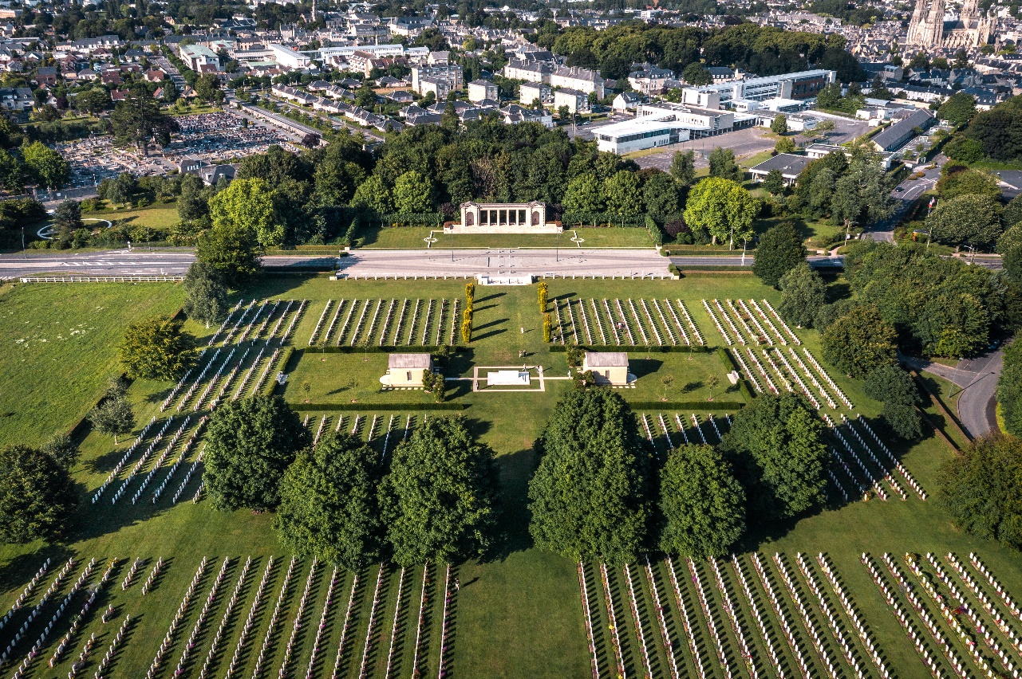

For Evermore: Stories of the Fallen

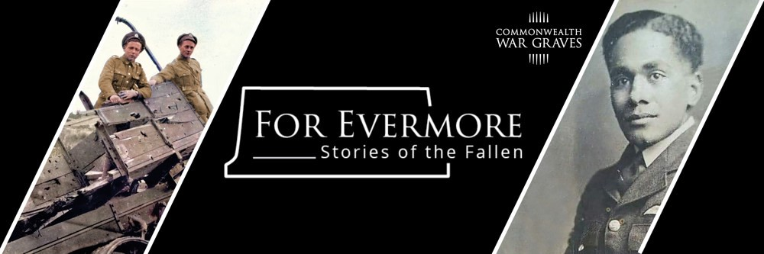
For Evermore: Stories of the Fallen – is a new online resource that will collect the stories of the fallen from the two world wars commemorated by the Commonwealth War Graves Commission.
For Evermore: Stories of the Fallen is an inclusive opportunity to remember the stories of the people we commemorate. We are inviting the public to upload stories of their relatives, loved ones or someone they have researched who today is commemorated at one of our cemeteries and memorials around the world.
We are collating your stories to create a single, searchable repository that honours the memory of the men and women across the Commonwealth who lost their lives during the world wars. Funded by our charity Commonwealth War Graves Foundation this resource ensures that these stories are available for the generations to come.
These memories will sit alongside our official record of commemoration, highlighting the person behind the name.
To date we have over 3,500 stories submitted. As part of the Legacy of Liberation 80 campaign we are asking the public for stories of the people who lost their lives during the Liberation of Europe.
Claire Horton CBE, our Director General, said: “The launch of For Evermore marks an incredibly important milestone in the Commonwealth War Graves Commission's mission. For Evermore will provide an opportunity for future generations to connect with their own history and learn more about those who served during the World Wars.
“By collating these stories in what will become the definitive resource of the stories of those who died in the world wars, we have created an enduring tribute to the men and women from across the Commonwealth who gave their lives, and we ensure that they will never be forgotten.”

Michelle Jennings, Chief Marketing Officer/Director of the Commonwealth War Graves Foundation, said: "For Evermore will enable the Commonwealth War Graves Foundation to fulfil our mission of ensuring those who fought and died during the world wars are never forgotten. It is only through the kind support of many generous donors that we will be able to keep these stories alive in such an engaging way.”

Walking Our War Graves: Normandy
A unique virtual fundraiser in honour of the 80th anniversary of D-Day

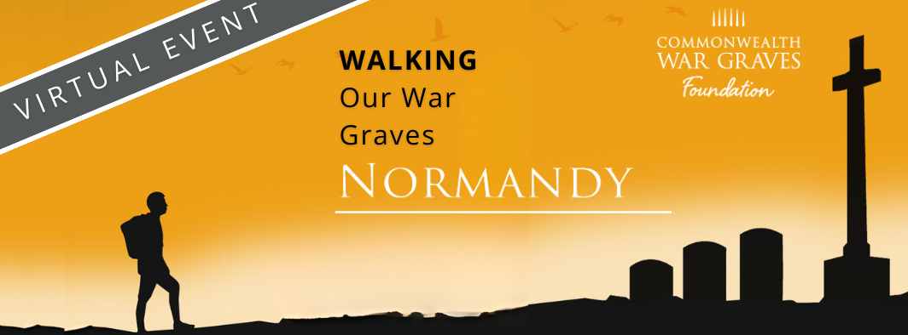
Honour Their Legacy With Every Step
A unique virtual fundraiser to discover more about the work of the Commonwealth War Graves Commission and read some incredible stories of sacrifice of those commemorated in Normandy, France.

Participants will be encouraged to join this year’s virtual route, stretching 95km across the Normandy region, chosen to mark the 80th anniversary of the D-Day Landings.
Participants can take part from anywhere in the world and this year’s interactive journey will start at Ranville War Cemetery/Ranville Churchyard. The route will finish at Bretteville-sur-Laize Canadian War Cemetery.
And of course, there will be stops along the way - including the well-known CWGC Bayeux War Cemetery.

All money raised will help support the Foundation’s outreach programmes such as our Eyes On, Hands On volunteers to our Guides working in France and Belgium.
Fundraisers who raise the most will be given the chance to have a wreath laid at Bayeux on their behalf.

During the event, participants will also be encouraged to visit their own local cemeteries to discover the history on their own doorstep.

Registrations are currently open and are due to close May 6th. Participants have until the end of May to complete the distance.
For more information: Fundraising activities and programmes | CWGF (cwgc.org)

About the Commonwealth War Graves Foundation (CWGF)
- The Foundation tells the stories of those who fought and died during the World Wars. As the charitable arm of the Commonwealth War Graves Commission, it’s our mission to make sure their sacrifices are not forgotten, and with your support, those stories will be kept alive.

- The CWGF aims to engage and educate people – especially the young – with the work of the Commonwealth War Graves Commission (CWGC) and the inspiring stories of the men and women who died whilst fighting in the two World Wars.

- With the help of our generous supporters, volunteers, and funders, we engage thousands of people through our innovative projects, providing opportunities to explore the legacy of the people, architecture, and heritage of the two World Wars.

- We actively involve young people through our work with schools, colleges, universities, and a variety of youth groups.

- We now have more than 300 expert speakers and tour guides who engage with people of all ages across the UK in schools, colleges, universities and through many different social and community groups.

- We also have a CWGF Guides Programme, which gives young history enthusiasts an incredible opportunity to work at some of Commonwealth War Graves’ most iconic sites in France and Belgium.

- People can leave a legacy for future generations. Remembering the CWGF by leaving a gift in your will, no matter what size, can help us in so many ways to inspire, involve and engage more people, especially the next generation, with our history of commemoration. Remember the foundation in your Will | CWGF (cwgc.org)

- To find out more about the CWGF, visit: https://foundation.cwgc.org/

Sustainability at CWGC
The Commonwealth War Graves Commission (CWGC) is committed to driving sustainability to tackle the key environmental concerns of our time, including climate change and the widespread loss of biodiversity.
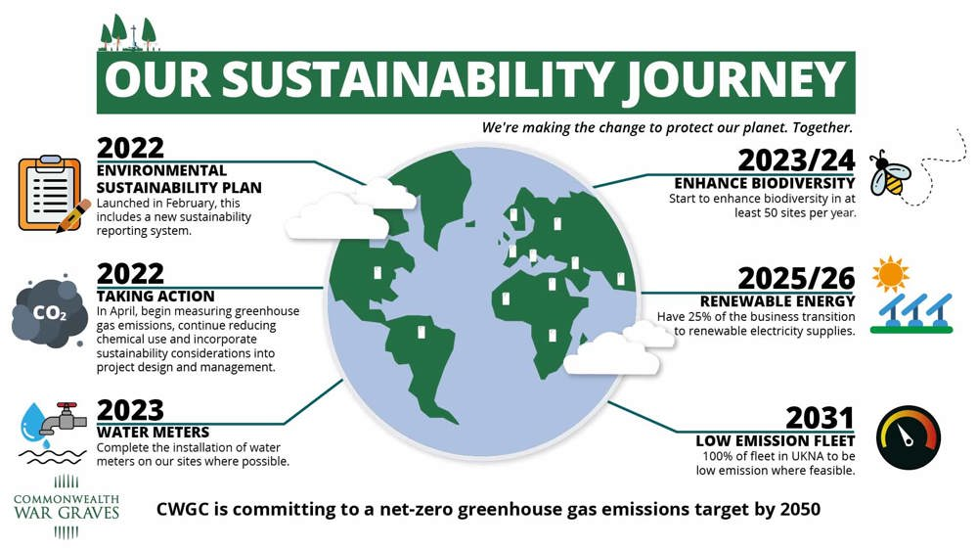
Our key sustainability messages:
- We are committed to conserving and maintaining our cemeteries and memorials today and for future generations.

- Sustainability is at the forefront of everything we do, to tackle today’s environmental concerns, including climate change and the widespread loss of biodiversity.

- We are progressively phasing out the use of harmful chemical products across the world. Cleaning products, such as biocides, accelerate damage and deterioration to our stone and using pesticides puts unnecessary chemicals into the environment.

- We are committed to achieving a net-zero greenhouse gas emission target by 2050, aiming to transition to 100% renewable electricity in as many sites as possible by 2031. We are encouraging use of electrically-powered machining and trialling use of EV vehicles and vans.

- The CWGC use more than twenty varieties of stone for headstones and grave markers, with many different styles which are not always white. We are committed to conserving them and ensuring legibility of the inscriptions.

- We use an enzyme-based cleaning product to treat algae growth, which is less impactful to the environment. Much of the algae-staining which grows on stone in northern Europe in winter will naturally disappear in spring and summer.

- Excessive cleaning damages the stone and the environment, so we now only clean headstones based on need.

- To enhance the carbon dioxide absorption potential of our estate, we are starting to review sites to establish where missing trees can be replaced (based on historical layouts) or where additional trees can be planted.

- We are actively seeking to reduce resource consumption and reduce waste generation. For example, to assist with reducing water consumption, we have been rolling-out a smart, software system that will enable us to better optimise and track the water consumed by our irrigation systems.

- We are a worldwide organisation, but we operate at a local level and new developments are constantly taking place as we transition to more sustainable ways of working – please do contact the media for more information.

- We are committed to creating a better environment to encourage diverse plants and insects across our estate. We’re committed to caring for our sites however we may reduce how often we mow and allow some wild plants to grow in the grass. We will also leave some areas uncut to promote biodiversity. Our cemeteries are havens for wildlife, and now some of them will have bird nesting boxes and bug hotels made from dead wood.

Examples of some of the issues we face are drought and flooding which are becoming a common occurrence at our cemeteries across the globe.
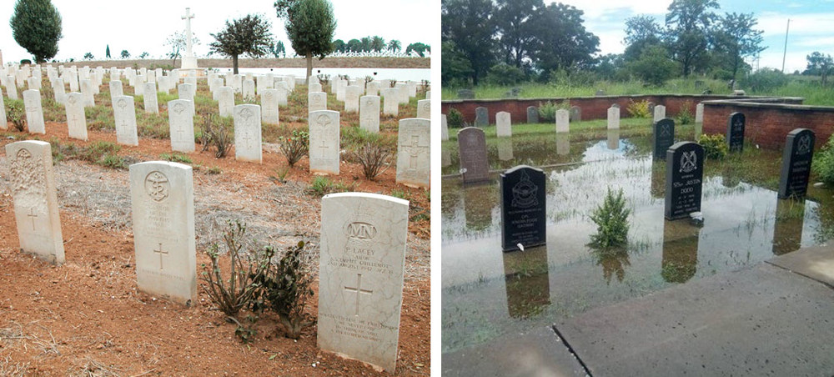

Example of a bug hotel at CWGC Brookwood Military Cemetery, UK
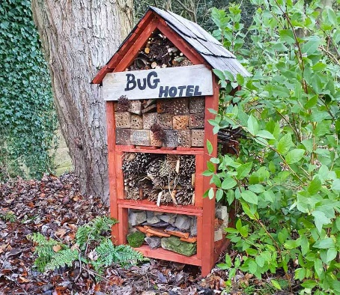

Press Releases
17/04/2024:
Commonwealth War Graves Commission issues warning on the future of World War commemoration.
- Commission calls on nation to spark national conversation to keep legacies alive ahead of 80th anniversary of D-Day
- Torch roadshow with national programme of events planned to inspire younger generations

The future of World War commemoration will be at risk without greater efforts to engage younger generations the Commonwealth War Graves Commission (CWGC) cautioned today, with only 50 days until the momentous 80th anniversary of D-Day.

The warning comes as the CWGC, the caretakers of war graves and memorials in over 23,000 locations worldwide, launches a programme of events which will reach hundreds of thousands of people across the country. Building connections between veterans and young people will be at the heart of the programme, in a bid to improve education and raise awareness of the courage, loss and sacrifice of the ordinary people who lost their lives during the Second World War.

Named ‘Lighting Their Legacy’ the 18 set-piece events will be held at different locations across the UK in May, supported by an educational programme for schools. During the events, flames of commemoration will be passed from veterans to young people to represent the handing over of responsibility for the memories of the World Wars to younger generations.

The torches have been designed by three Canadian undergraduate Mechanical Engineering students from McMaster University in Ontario. They were tasked to overcome the challenges and technicalities needed to build a torch, including the weight and fuel, as part of a degree project which allowed them to reflect on why commemoration is important to them, and why it continues to be relevant for future generations.

The journey of the living flame of commemoration will start in Canada, and in the UK will include Cardiff, Edinburgh, and Portsmouth, as well as key Commonwealth War Graves locations. The events will culminate in Normandy, with every CWGC grave being lit in tribute to the fallen.

Claire Horton CBE, Director General of The Commonwealth War Graves Commission, said:

“We are at an undeniable turning point for the legacy of commemoration. This year’s landmark anniversary may be the final major commemoration attended by veterans of D-Day, and as such represents a unique opportunity to pass on the torch of commemoration from the generation who fought in the two World Wars, and ensure commemoration of their legacy endures for generations to come.

“As we look to the future, better education must play a vital role in ensuring that the lessons of the First and Second World are remembered, and that the importance of commemoration is understood by everyone, whether you have a direct and personal connection to the World Wars or not. Our mission is for the legacy of those who died fighting for our freedoms to inspire a world free from conflict.

“This year serves as a turning point for renewed national commemoration and pride, and we are calling on everyone to reflect on the Legacy of Liberation passed on to us by those who gave their lives in the conflicts of the First and Second World Wars and share with your friends, family, and communities your personal reason for why commemoration is important to you. We encourage you to learn about the Second World War and share your stories on our For Evermore platform, and if you can, join us at Bayeux War Cemetery in Normandy or spend time at a local CWGC site near you.”

NOTES TO EDITORS

For further information, please contact cwgc@plmr.co.uk or 0800 048 7031.

About the Commonwealth War Graves Commission
The Commonwealth War Graves Commission is the global leader in commemoration, trusted by Governments and founded by Royal Charter in 1917. Our mission is to ensure that the men and women who died in the First and Second World Wars are commemorated so that they, and the human cost of war, are remembered for ever.
CWGC’s expert team includes the world’s leading horticulturists and historians who care for and maintain 23,000 war memorials and cemeteries in 150 countries.

Through our charitable Foundation, we educate and share the inspirational stories of people who fought and died in the World Wars.

CWGC will play a central role in the global events organised to mark the 80th anniversary of D-Day.

Lighting Their Legacies – UK locations (full list to be confirmed)

- Bath
- Cambridge
- Cardiff
- Edinburgh
- Harrogate
- Kent
- London
- Manchester
- Oxford
- Plymouth
- Portsmouth
- Surrey
- Staffordshire - National Memorial Arboretum

